## One Click Installation

1. Open up your browser window and go to your CSUF Portal: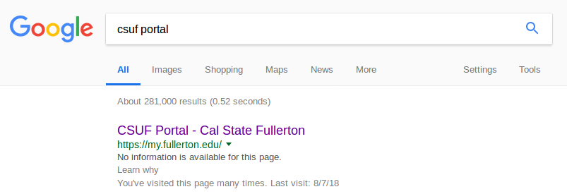
2. Go to left hand corner and click on Titanium:

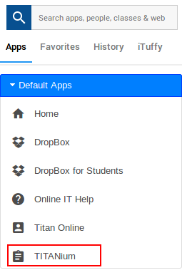

1. Navigate to Communities:
2. If you are not enrolled in the Tuffix Community, please follow [these steps](https://docs.google.com/document/d/1HZtBl9qtT-9t1mU6LAmXn3_ayCfMni39GNLFGQ14s4M/edit):
3. Head over to the Tuffix Students Community: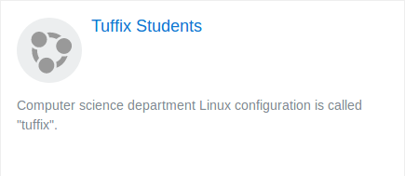
4. You will find a header called “Tuffix VM .ova Files” and click the top link. The links will be variable so do not worry if this not the first link for you: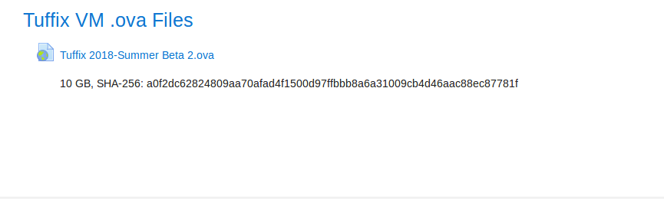
5. You will be redirected to a Google Drive page and you need to click download: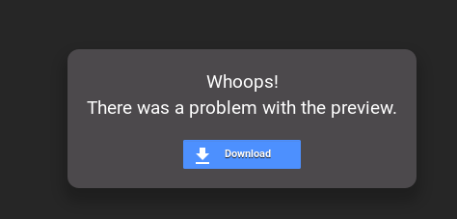
6. Again you will see a page telling you it cannot scan for viruses and that okay:
7. This will take a while depending on your computer and internet speed so sit tight
8. Once it is done downloading, proceed to open VirtualBox and click the File drop down: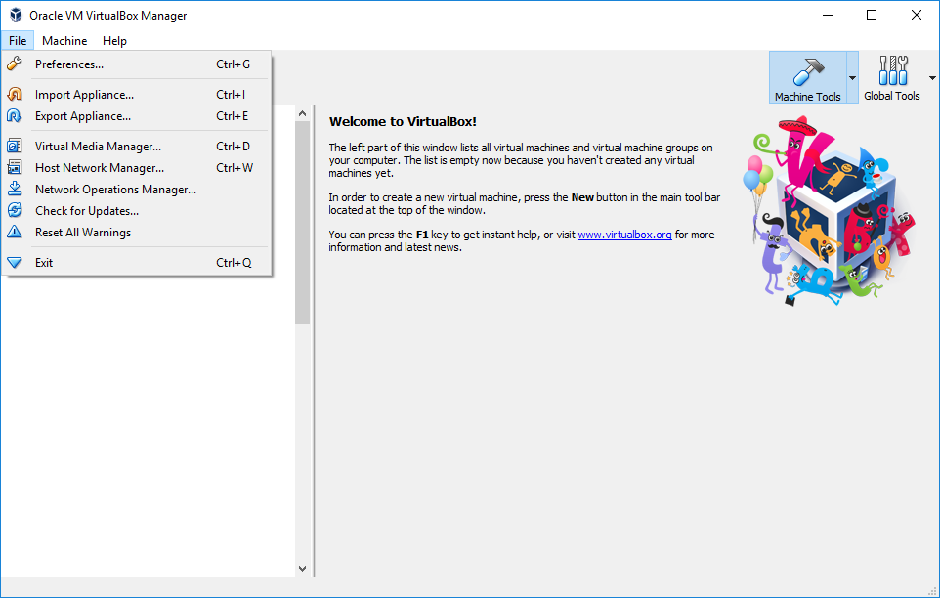
9. Click on “Import Appliance” and you will see a screen like this: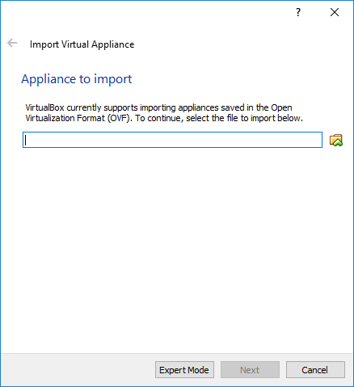
10. Navigate to where you downloaded the Tuffix File: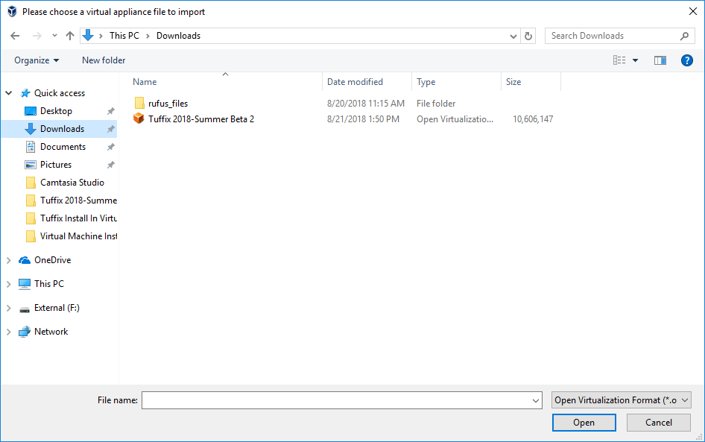
11. Once you click “Open”, this window will populate with the path (location) where your file is: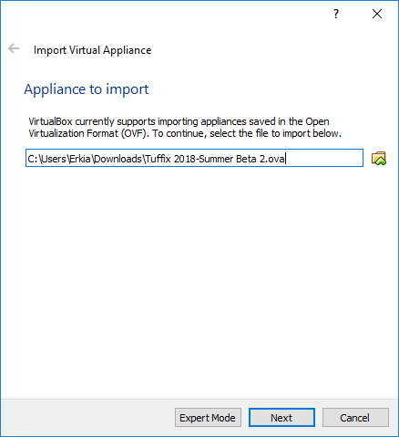
12. Press “Next” and you will be able to edit the settings of this Virtual Machine. Please leave them to the defaults if you don’t know what they are: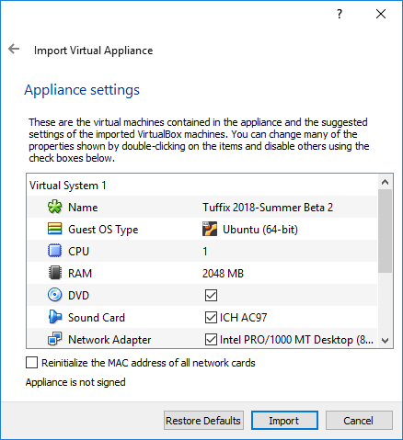
13. Clicking “Import” will bring you this dialog and this will take a while: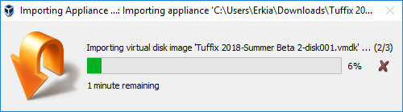
14. Once it is done, you should see this:

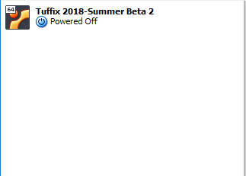

1. Right-click on the Virtual Machine and press Start → Normal and you’re all done: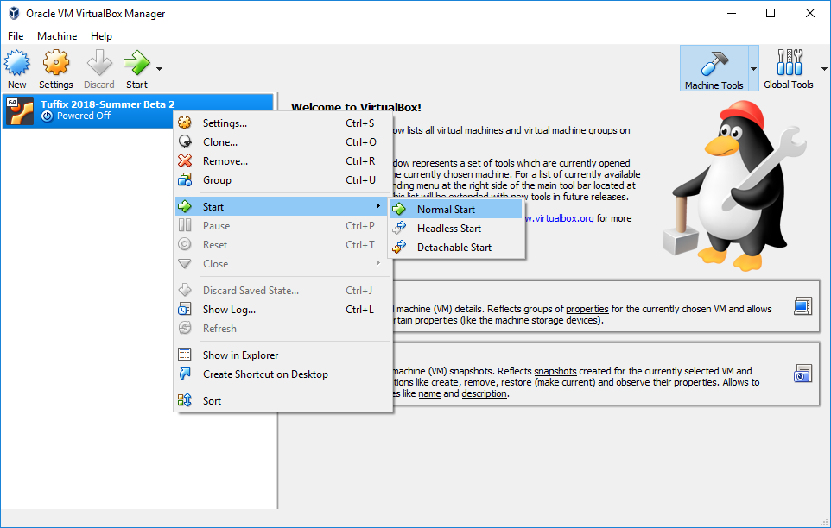
2. Proceed to [this document](https://docs.google.com/document/d/1vPstnG13N6nq4HyQLJJ2KHRkkhbBzCssTYLkcY3i0ts/edit) for further information regarding Tuffix